**Assignment 3-Robinson Folds Distance using Days Algorithm for 3 dree Tree.**

**Created by: Kaitav Mehta 104911444**

**Input Guide:**

There are two ways user can test this program 1) Default Tree Input 2) Manual Tree Input

User can test the program on default Tree Input by Pressing 1 at the beginning of the run.

**Default Trees:**

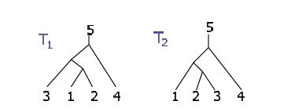

Robinson Fold Distance for the above Tree is 1.

**Manual Tree Input:**

User can test the program on default Tree Input by Pressing 0 at the beginning of the run.

**Below steps are mentioned to create above tree T1 manually.** Follow Similarly to create any other tree where you want to calculate Robinson Fold’s Distance.

1. The Tree is created in Preorder Insertion.
2. For empty node 0 is used.
3. Enter value of node, if its the leaf node then end the tree branch by adding -1 for both left and right child. Keep track of preOrder while creating tree.
4. Enter negative value if a node doesn’t have a specific child

Below is the Input order for Tree T1. Similarly add the tree T2.

And viola, check the Robinson Fold Distance.

-Please email me ([mehta128@uwindsor.ca](mailto:mehta128@uwindsor.ca)) if there is any problem in understanding the Manual Input of Trees.

